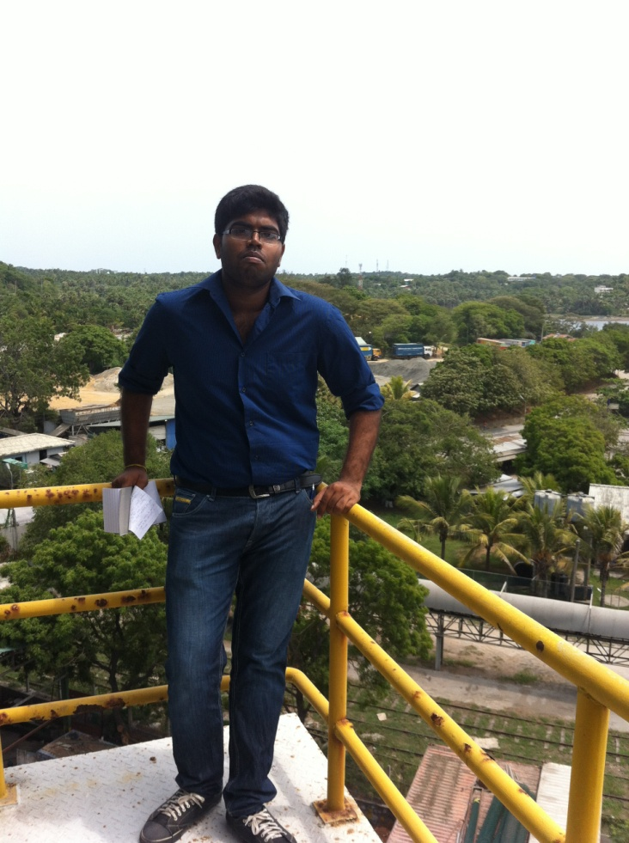**IyaSamySarmaThuranthakan**

**Personal Details: -**

Date of Birth: - 03.09.1993

Age: - 21

Status:- Single

Nationality: - Srilankan

NIC No: - 932470888v

Sex:- Male

Blood Group: - A+

Permanent Address: - 70A, 5/3, Pamankada Road, Colombo 06

Telephone No: - 0773924070

Email ID: - [thuranth93@gmail.com](mailto:thuranth93@gmail.com)

Language Known: -

* Tamil Fluent
* English Average
* Sinhala Average

**Education:-**

* Following Mechanical Engineering Degree in Esoft Engineering Campus (BSc (hons) in Mechanical Engineering – Kingston University, UK).
* From 2013 to 2015 Higher National Diploma in Mechanical Engineering in ICBT Mount Campus.
* 2012 Advanced Level in Colombo Hindu College

First Attempt

|  |  |
| --- | --- |
| Combined Mathematics | S |
| Physics | S |
| Chemistry | F |
| General English | S |

Second Attempt

|  |  |
| --- | --- |
| Combined Mathematics | C |
| Physics | S |
| Information Communication Technology | C |
| General English | B |

* 2009 Ordinary Level in Colombo Hindu College

|  |  |
| --- | --- |
| Mathematics | A |
| English Language | B |
| Tamil Language | A |
| Science | C |
| Commerce | A |
| Religion | A |
| Health Science | A |
| History | B |
| Music | B |

**Experience: -**

* 4 months working experience in Tokyo Super Cement Factory (in both Biomass Power Plant And Cement Factory)

**Other Qualifications: -**

* Completed Diploma in Computer Basics
* Completed Diploma in MS Office
* Completed Diploma in Hardware Engineering

**Skills: -**

* Quick to adapt and learn new environments and skills
* Capable in engineering design and manufacture
* Capable in using Solid Works or SolidCam software to design engineering models.
* Competent with use of computer hardware or software, C++ language, documentation and able to handle internet tools.

**References: -**

* F. Ranganathan

Consultant,

Early Childhood and Primary Education,

Faculty of Education,

Open University of Sri Lanka,

Nawala,

Nugegoda.

0776366415.

* Lion K. Kulatheepan (MJF)JP

Government Contractor

120, Karunannivasa Road,

Linganagar,

Trincomalee.

0777666121.

I hereby certify that the above information is true and correct to the best of my knowledge.

________________________

I. Thuranthakan